

**FOR HIRE**

**Ifor Williams LM105 Drop Side Trailer**

**(9.9 x 5.5ft)**

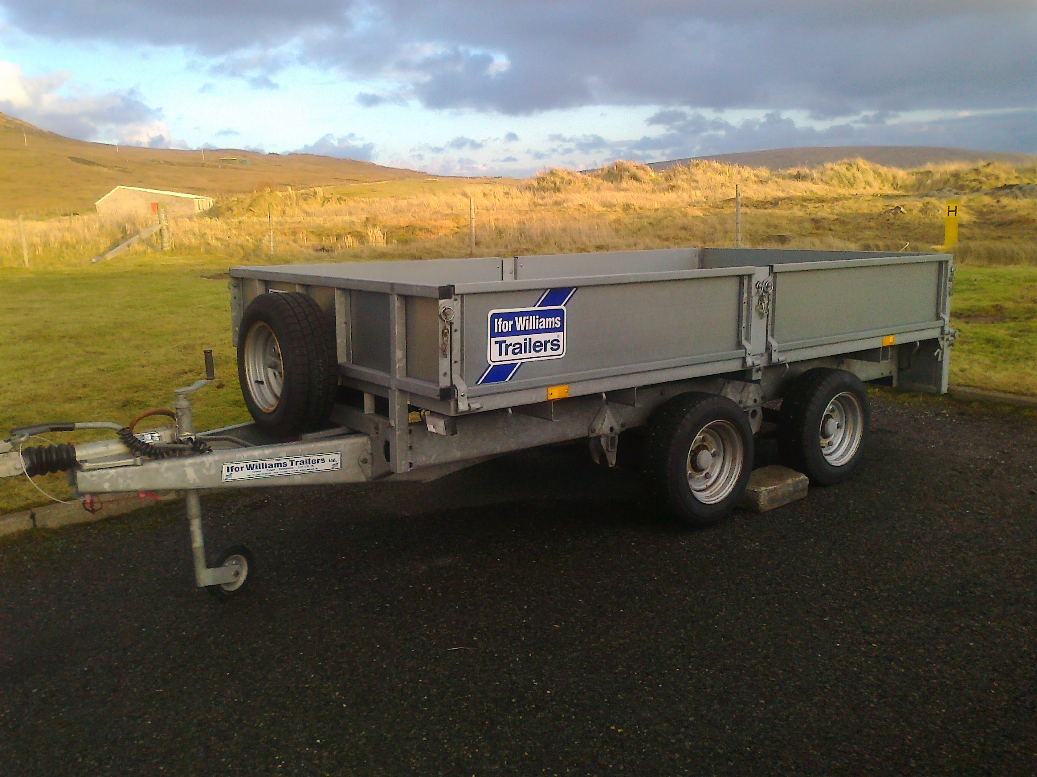 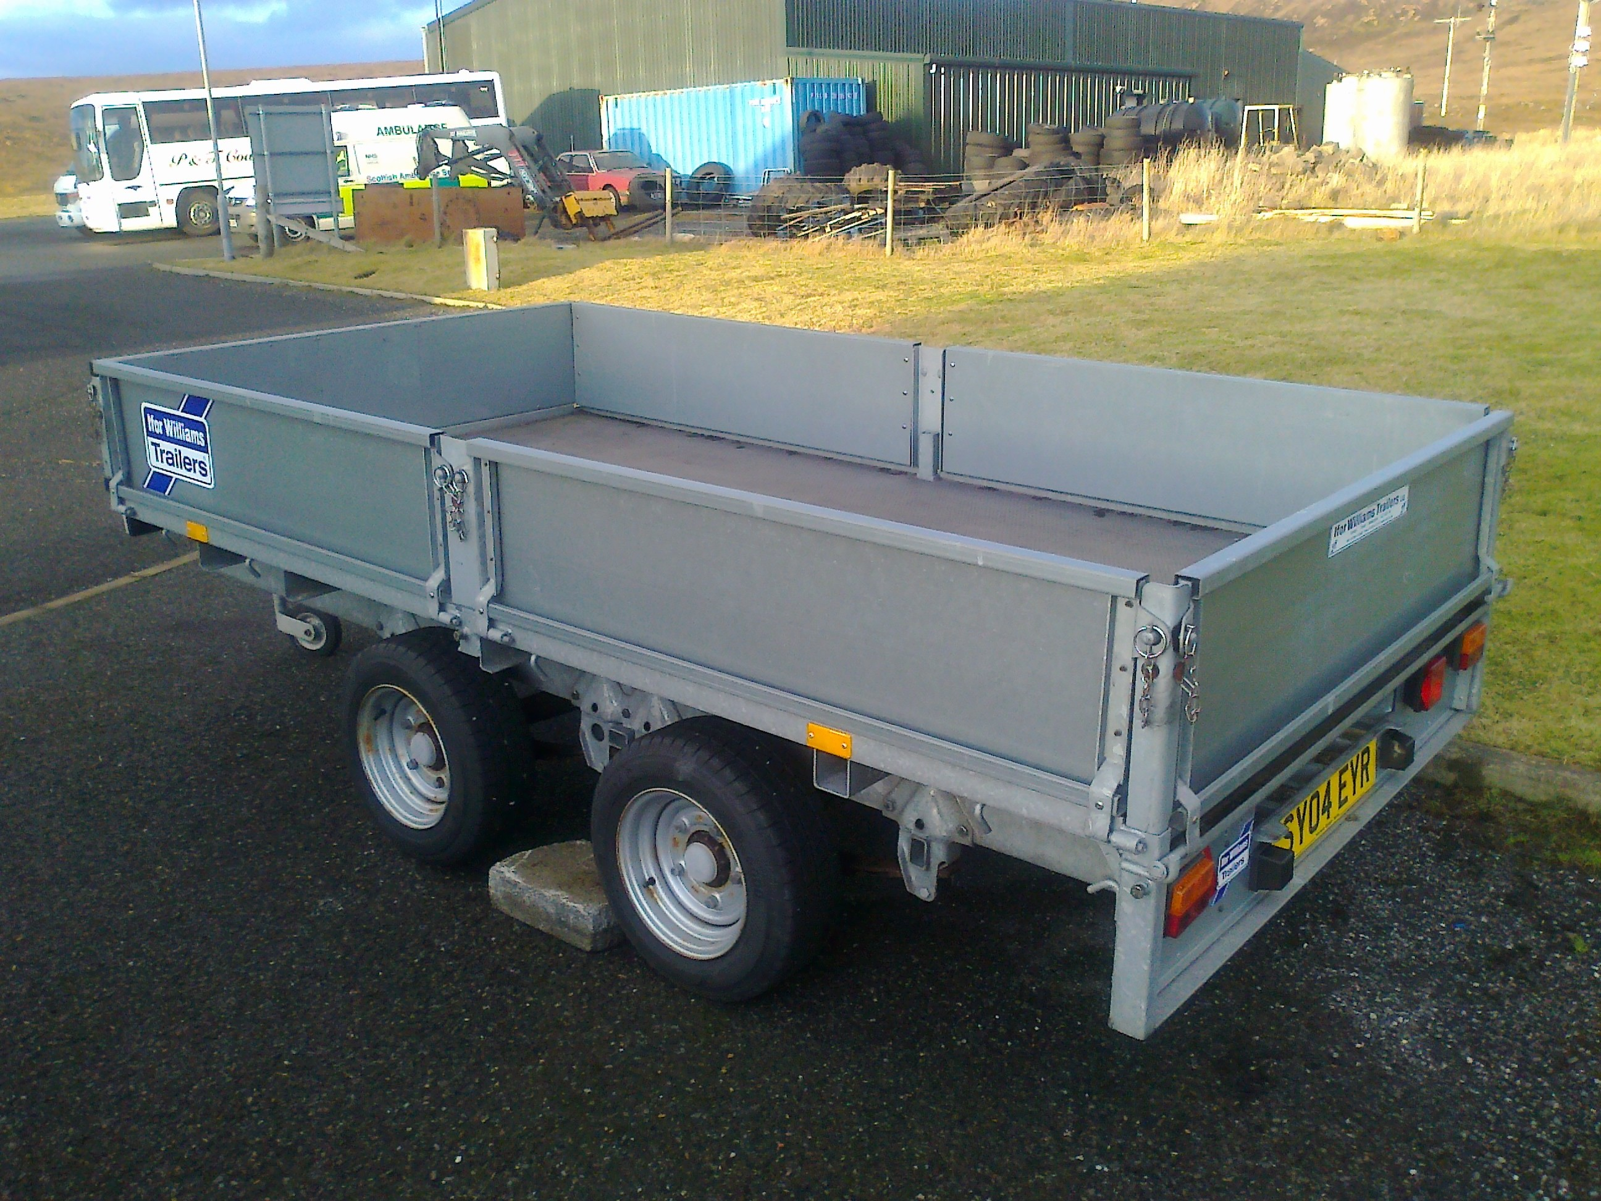

**Rate: £15 + VAT half day (12 hours)**

**£30 + VAT full day (24 hours)**

**£50 + VAT weekend**

**Payment: Cash/Cheque/Invoice**

**Borrower must have sufficient and safe vehicle to tow trailer with appropriate licence and insurance cover in place.**

**Signed hire agreement essential.**

**Contact Verona Shaw on 01957 711495 or email** [**up@unst.org**](mailto:up@unst.org)